
If you have any safeguarding concerns about the safety of your own child or anyone else’s child during the school day, please contact the nominated person (DSL) for child protection, Mrs Rosie Kerr (Head Teacher) is also the nominated person for Children in Care.
Wickhambrook Primary Academy
Safeguarding Children
In her absence the next person to contact is Miss Cara Shore (DDSL), Mrs Julie Buck (ADSL), Mrs Sophie Wearing or Mrs Dana Phillips (ADSL). If the concern is regarding PREVENT, please see below.
If a child makes a disclosure when the above Safeguard Leads are not on the premises and you consider the child to be at risk or significant harm you must contact one of them starting with Mrs Rosie Kerr.
Should you be unable to contact Mrs Kerr please ask in the office for Miss Shore, Miss Buck, Mrs Wearing or Mrs Phillips. Alternatively, you should be able to contact them, on their mobile phone numbers. It is your responsibility to ring the consultation line on the numbers below with the concern. The concern and action must be recorded on a yellow sheet and handed to a Safeguard Lead.
For Safeguarding issues please contact:
Customer first: 0808 800 4005 (Monday-Friday: 8:45- 17:20)
OR
Out of hours: 0800 800 4005
Prevent Concerns: If you have a PREVENT disclosure/concern during the school day, please see Mrs Rosie Kerr, Miss Cara Shore, or Mrs Julie Buck who will decide whether to refer to Channel Panel. If a child makes a PREVENT disclosure when the above Safeguarding Leads are not available and there is an imminent risk of harm it is your responsibility to contact the police on 999.
All disclosures/concerns must be recorded on CPOMS
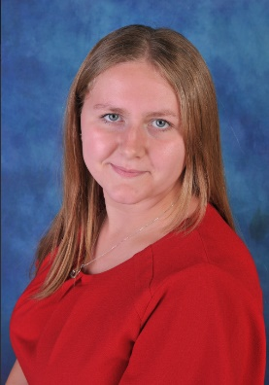
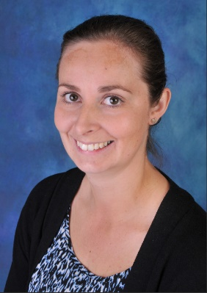
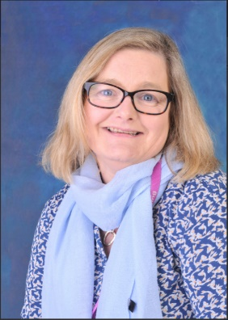
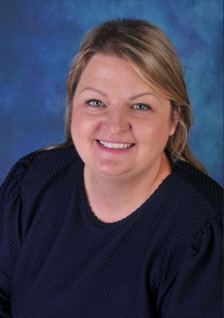
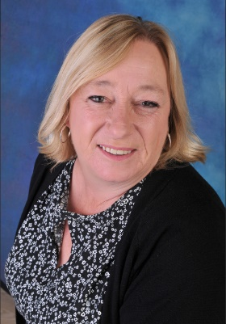
Mrs Rosie Kerr Miss Cara Shore Mrs Julie Buck Mrs Sophie Wearing Mrs Dana Phillips

